Colome City Council

Regular Meeting Minutes

April 11th, 2023

Mayor Brad Hill called the meeting of the Colome City Council to order at 6:59 PM at the Colome Fire Hall. The council members present were Duffy, Heese, Leighton, Dougherty, and Nelsen. Beckers was absent. Also present were Utility Manager Casey Harter, Finance Officer Bobbi Harter, Attorney Alvin Pahlke, Becky Brunsing, Summer Kutz, Rachel Bolie, Jim Poler, Kris Hauf, Roger Hauf, Kutis Atteberry, Candy, and David Cahoy. The meeting was opened with the Pledge of Allegiance.

**Agenda Discussion/Corrections/Approve** Motion by Heese second by Leighton to approve the agenda as written; All members voted aye; the motion carried.

**Approve Meeting Minutes of March 7th, 2023, and March 21st, 2023,** Motion by Leighton Second by Heese to approve the meeting minutes as written. All members voted aye; the motion carried.

**Recognition of Visitors**

*Mike Scott:*Discussion was held on the Winner Area Chamber of Commerce Hosting summer nights in Colome on August 11th, 2023, on main street. Motion by Duffy Second by Heese to approve summer nights event. All members voted aye; the motion carried.

*Kris Hauf:* came to the meeting to give an update on the city park equipment that will be arriving.

*Roger Hauf:* came to the meeting to give the council an update on the dog issue he has been having.brought to the councils’ attention the safety of all the citizens in town with the dogs running at large and not licensed with the city.

*Candy Cahoy:* came to the meeting with concerns on the health hazard of the dogs that are running at large.

*Rachel Bolie:* came to the meeting to discuss with the council what her plan is this summer to control her animals.

**No Public Input**

**Claims to Approve**

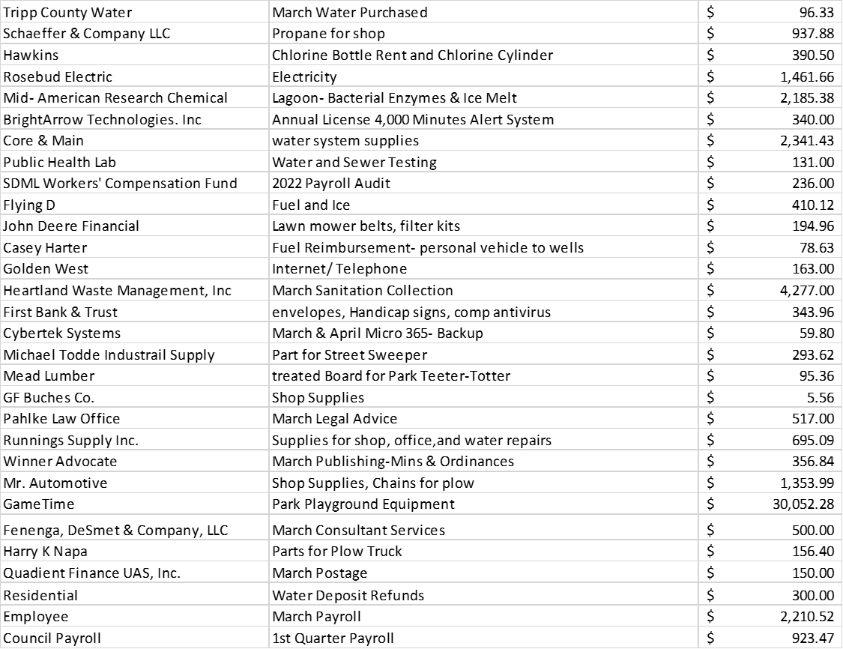

Motion by Duffy second by Leighton to pay the claims. All members voted aye; the motion carried.

**Financial Report**

Accountant Dan DeSmet was not present. Finance Officer Harter provided the financials for April to the council. Motion by Heese Second by Leighton to approve the Annual Report. All members voted aye; the motion carried.

**Utility Manager Report**

Utility Manager Harter gave his report.

**Old Business:**

*Becky Brunsing*

Discussed with council the results of the Quote for Insurance.

*Ordinance Ticket Book*

The Ticket book has been ordered.

**New Business:**

*Building Permits*

Motion by Leighton Second by Nelson to approve part of Jim Poler’s building permit for a small cover over AC unit located on the north side of his building and to Table the rest of Jim Poler’s Building Permit to the next meeting of May 2nd. All members voted aye; the motion carried.

*Liquor Licenses*

Motion by Heese second by Duffy to approve the 2023-2024 Application for the RB License submitted by the Flying D. All members voted aye; the motion carried.

*Spring Clean up*

It was discussed and agreed to get a Dumpster from Jim’s Garbage Service for Spring Cleanup.

*DOT- Sweeping Contract*

Motion by Nelsen Second by Dougherty to raise the amount to $125.00 a hour for the sweeping contract. All members voted aye; the motion carried.

*Utility Manager Evaluation*

The HR Committee with schedule a time to meeting with Utility Manager Harter before the next regular meeting.

*Surplus Property Blk 3 Lots 18-22*

Discussion was held on the property.

*Surplus Property Blk 16 Lot 11*

Moton by Heese second by Duffy to start the Quiet Title Action on the property All members voted aye; the motion carried.

**Executive Session:**

Moton by Leighton second by Duffy to enter into executive session at 9:27pm for legal counsel per SDCL 1-25-2(3), motion carried 6-0. Mayor removed council from executive session at 9:39pm for legal counsel per SDCL 1-25-2(3), Upon exit motion was made by Leighton second by Nelsen to have a title search done on Parcel 50.23.23.06 and Parcel 50.33.33.04

Motion by Duffy second by Dougherty to adjourn the meeting at 9:53 pm; All members voted aye; the motion carried.

_________________________

Brad Hill, Mayor

ATTEST:

Finance Officer, Bobbi Harter

"This institution is an equal opportunity employer and provider."

Published once at the approximate cost of ____