ORDINANCE NO. 2021-1

AN ORDINANCE PROVIDING FOR COLLECTION AND DISPOSAL OF

GARBAGE, RUBBISH AND WASTE MATERIAL AND SETTING THE FEES

THEREFORE

AN ORDINANCE amending Ordinance No 109, 125 and 179 entitled "AN ORDINANCE PROVIDING FOR COLLECTION AND DISPOSAL OF GARBAGE, RUBBISH AND WASTE MATERIAL AND SETTING THE FEES THEREFORE."

BE IT ORDAINED BY THE CITY COUNCIL OF THE CITY OF COLOME, SOUTH DAKOTA:

SECTION 1. DEFINITIONS

1. The word "garbage" used herein shall be defined and described as all organic refuse from preparation of feed and decayed or spoiled animal or vegetable food from any source.
2. The word "rubbish" as used herein shall be defined and described as all combustible inorganic refuse matter, such as papers, sweepings, rags, wood shavings, etc., originating from the ordinary household or business operations.
3. The words "waste material" as used herein shall be defined and described as all non-combustible inorganic matter, such as glass containers and metal originating from ordinary household or business operation but shall not include body waste of human or animal origin.
4. A "family domestic" unit for the purpose of this Ordinance shall be deemed to be, and mean any single independent family unit, irrespective of the number of persons constituting such family. Each independent family unit living in multiple dwelling residences, apartment houses, or any type of residence including purposes of this Ordinance. Every family domestic unit within this City shall be required to pay the collection and disposal fee as prescribed by Section 6 hereof upon the tenth day of each month. The contractor shall notify the city for any changes in the monthly charges.

SECTION 2. DEPOSIT OF REFUSE

It shall be unlawful for any person to deposit or cause to be deposited any garbage, rubbish or waste material in or upon any park, street, alley, gutter or in or upon any other private or public property within this city.

SECTION 3. RESIDENTIAL WASTE RECEPTACLES

A. Every household or occupant of a family domestic unit will be provided a 90-gallon receptacle (assigned by a number on the container to matched to the residence). The receptacle will stay with the dwelling in which it was assigned when the occupant moves. The residential waste receptacles shall be placed that collectors of garbage do not have to carry such containers for a distance of more than 20 feet. Where there is a through alley, the receptable may be placed to the adjoining premises.

a. The following will not be accepted:

Grass clippings and branches, ashes, animal carcasses, tires, batteries of any type, scrap metal, propane tanks, appliances, furniture/mattresses, concrete/rock/brick, asbestos, paint, herbicides, hazardous waste liquids, grease.

SECTION 4. COMMERCIAL ESTABLISHMENTS

All commercial establishment within this city having garage, rubbish or waste mater to dispose of, which cannot be contained in a ninety (90) gallon container, shall utilize dumpsters of sufficient size to receive all refuse which may accumulate between by or provided by the commercial hauler at the establishment's expense. These containers shall be located at the rear of the building or property using the same so it can be easily accessible to by the collector.

SECTION 5. RATES FOR SERVICE

The Council shall set the rates for the collection and hauling of garbage and refuse. Payment shall be made monthly at the at the City Office/ACH Withdrawal/Credit Card. The City Manager will assess the monthly rates for the various sizes of the receptacles. The amount shall be included with the water and sewer charges. The garbage and refuse charge will be charged the appropriate sales tax in each billing. The amount is due on the tenth (10th ) of each month with a 20% penalty if not paid by the twenty fifth (25th ) of the same month. Failure of the person responsible for the payment of the fee for family domestic units or the owner of commercial establishments to pay the collection charges when due and abide by all other provisions of this ordinance will constitute grounds for the termination of water service.

A. The cost of the residential 90-galJon receptacles shall be

1. Regular customers - $24.75
2. Senior customers (70 and over) - $21.50
3. Small commercial - $36.00
4. Medium commercial - $65.25
5. Large commercial - $95.50

SECTION 6. COMMERCIAL GARBAGE HAULERS

1. A commercial garbage hauler for the purposes of this Ordinance shall be defined as any person who hauls or transports any garbage, rubbish or waste material through or upon the streets or alleys of this City to a waste disposal facility, for a consideration or a fee, or as part of a business activity.
2. It shall be unlawful for a commercial garbage hauler to haul or transport any garbage, rubbish or waste material through or upon any street or alley of this City for a consideration of a fee, or as a part of a business activity unless he is the holder of a license in full force and effect, authorizing him to do so a provided for herein.
3. The City Council is hereby empowered to negotiate and from time to time change any rules and regulations necessary for the conduct of commercial garbage haulers. It shall be unlawful for the commercial garbage haulers to haul garbage or rubbish in a truck or trailer unless the truck or trailer is covered so that trash, garbage or rubbish will not be strewn along the streets of the City.
4. Any commercial garbage hauler violating any of the terms of this Ordinance shall be subject to forfeiture of their license.
5. The commercial garbage hauler shall be responsible for hauling all garbage collected to an approved landfill or transfer point.
6. The commercial garbage hauler shall be responsible for paying all dumping fees. The license of any commercial garbage hauler who fails to pay the dumping fee when due shall automatically be cancelled and revoked and a new license may not again be issued until all past due dumping fees are paid.

SECTION 7. OPERATION AND ENFORCEMENT

The operation and enforcement of this Title shall be vested in the Mayor and City Council.

SECTION 8. VALIDITY OF ORDINANCE

If any section, part or provision of this Ordinance or the application thereof to any person, firm or corporation, or to any circumstances, shall be held invalid for any cause whatsoever, the remainder of this Ordinance or the application to persons, firms or corporations or circumstances other than those as to which it is held invalid shall not be affected thereby, and shall remain in force and effect as though no part thereof had been declared to be invalid.

SECTION 9. CONFLICTING ORDINANCES

That all Ordinances and parts of Ordinances in conflict herewith are hereby repealed.

SECTION 10. EFFECTIVE DATE

This Ordinance shall be effective twenty (20) days after its approval, passage and publication.

APPROVED

Brad Hill, Mayor

ATTEST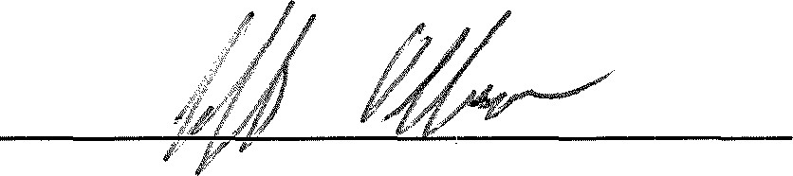

Jeff Ohlmann, Finance Officer/Public Works Director

Date of ISt reading:May 3, 2021



Date of 2 nd reading: 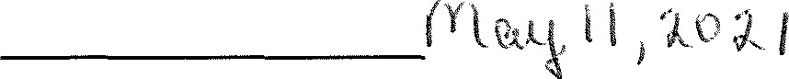

Date of passage: 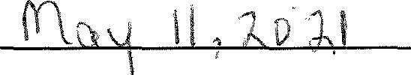

Date of Publication: January 25th, 2023